### SECTION V

# Honours and Awards

**CONTENTS**

Contents

SECTION V 1

Honours and Awards 1

The Most Honourable Order of the Bath 4

The Most Exalted Order of the Star of India 5

The Most Distinguished Order of St Michael and St George 6

The Most Eminent Order of the Indian Empire 7

The Most Excellent Order of the British Empire 8

Knights Bachelor 9

The Most Venerable Order of the Hospital of St John of Jerusalem 10

ACADEMIC 11

Adam Smith College 11

Babcock & Wilcox Student Engineering Apprenticeship 11

Caltex University Scholarship 11

Dundee Technical College 11

Armitstead Silver Medal 11

Bruce Ball Medal 11

Dunfermline Carnegie College 11

Educational Institute of Scotland 11

Ernest Scheller III Memorial Scholarship 11

Institute of Biology Prize 11

Institute of Physics Prize 11

Modern Studies Educational Trust 11

Certificate of Excellence 11

Higher Trophy 11

Nuffield Foundation 11

Certificate 11

Science Bursary 11

Queen’s College, Dundee 11

Clyde Henderson Bursary 11

Myles Bursary 11

Robert Adam Memorial Prize for Mathematics 11

Royal Academy of Engineering 2

Scottish Association of Geography Teachers 2

Scottish Mathematical Council 2

Award for Outstanding Performance 2

Senior Maths Challenge 2

Tullis Russell Scholarship 2

UK Maths Challenge 2

(Junior) 2

University of Aberdeen 2

Henderson, Ruddiman and Bruce Bursary 2

Honorary Doctor of Divinity 2

Rose Bursary 2

University of Birmingham 2

University of Dundee 2

Biochemistry Prize 2

British Association Medal 2

Bursary Competition 2

**University of Edinburgh** 2

Bursary in English 2

Cowan House Entrance Scholarship 2

Maule Bursary 2

**University of St Andrews Blue** 4

**Scottish Sports Council** 4

**Scottish Sportswoman of the Year** 4

The Most Honourable Order of the Bath

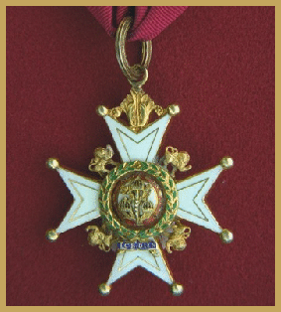Companion

John James Andrew Reid

The Most Exalted Order of the Star of India

Commander

Bertie Munro Staig

The Most Distinguished Order of St Michael and St George

Knight Commander

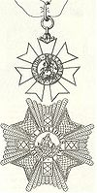

John James Andrew Reid

The Most Eminent Order of the Indian Empire

Knight Commander

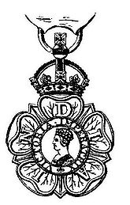Bertie Munro Staig

The Most Excellent Order of the British Empire

Commanders

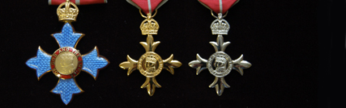Barclay James Bennett

Alasdair M Breckenridge

Robert Craig

Marshall Meek

Officers

James Anderson

Andrew Arbuckle

Joyce Blow

David Carse

Hector Davidson

Alexander McBride Davis

Alexander French

John Hunter

Ian MacGregor

Will Maclean

Dale Reid

Members

Malcolm Buchanan

Caroline Innes

Mary Law

Joan Barrie Lawrence

David B Martin

Alexander Maxwell

Brownie Melville

Ronald Melville

Doreen Millar

Margaret Paisley

Arthur Tresize

British Empire Medal

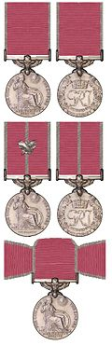

Carra McNeil

Alexander Maule

Knights Bachelor

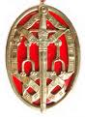

Alasdair M Breckenridge

Robert Paul Reid

Robert Robertson

Bertie M Staig

The Most Venerable Order of the Hospital of St John of Jerusalem

Member

Jean C Liddell

# ACADEMIC

Adam Smith College

Best Overall Student of the Year

2010 Karen Drummond

Babcock & Wilcox Student Engineering Apprenticeship

Angus C McNicoll

Martin C K Pope

Caltex University Scholarship

Geoffrey W Paton

Dundee Technical College

Armitstead Silver Medal

Ronald Rennie

Bruce Ball Medal

Ronald Rennie

Dunfermline Carnegie College

Honorary Fellow

Angus Hogg

Educational Institute of Scotland

Fellow

John Wilson

Ernest Scheller III Memorial Scholarship

Anne Watson

Institute of Biology Prize

Philip Attwood

Institute of Physics Prize

Stephen Terwey

Modern Studies Educational Trust

Certificate of Excellence

Kathryn Reed

Higher Trophy

Lucy Aitken

Nuffield Foundation

Certificate

Louise Robertson

Science Bursary

Adam Bates-Gray

Douglas Tyndall

Queen’s College, Dundee

Clyde Henderson Bursary

Neil Cameron

Geoffrey W Paton

Myles Bursary

Eric A Betsworth

Robert Adam Memorial Prize for Mathematics

Sarah Burnet

Thomas Porter

Matthew Rodger

Royal Academy of Engineering

Fellow

Marshall Meek

Scottish Association of Geography Teachers

World Wide Quiz

Winners

2005 Fergus McCool(S4), Philippa Turnbull(S3) & Daniel Hill(S2)

Scottish Mathematical Coun­cil

Award for Outstanding Performance

Gregor Dick

Senior Maths Challenge

Gold Medal

2008 Megan Griffiths

Silver Award

2010 Brett Lindsay

2010 Nick Fisher

2010 Callum Rearie

Bronze Award

2010 Ben Logan

2010 Jack Wright

2010 Eilidh Johnston

2010 Scott Yaxley

2010 Kirstin Murie

2010 Catriona McBride

2010 Adam Bates-Gray

2010 Alistair Bell2010

2010 Jonathan Failes

2010 Fiona Cuthill.

Tullis Russell Scholarship

Stephen Balsillie

UK Maths Challenge

**Gold**

2011 Hannah Greenlees

2011 Norman MacGregor

Silver Award

2012 Calum Winter

Bronze Award

2012 Tom Beaver

2012 Margaret Mellon

UK Maths Challenge

(Junior)

**Gold**

2011: Jordon Brown, Gemma Crowe, Ewan Jenks, Fraser McCallum, Cameron Strang, Jack Weir, Shane Wilson

2012: Ewan Jenks, Norman MacGre­gor, Liam Turner, Ailsa Winter, Harry Winter

Silver

2011: Rachel Burgess, Abigail Curnming, Shaun Finnigan, Owen Green, Adam Harris, Brad Lambie, Laura McConnell, Jonathan Munro, Alastair Nimmo, Phoebe Reid, Holly Rosserter, James Strachan, Sietse De Vries, Skye Wilson, Ailsa Winter

2012: Callum Fox, Adam Knox Ailidh McCall, Morgan Macfie, Andrew Mellon, Jennifer Patrick, Cameron Strang

Bronze

2011: Kieran Brough, Angus Evans, Ben Guthrie, Calum Heggie, Nicola Howat, Sean Morgan, Daniel O'Connor, Sarah O'Donnell, Chloe Rawcliffe, Jack Richardson, Euan Robertson, Liam San Roman, Robin Shears, Samantha Sloan, Alex Strachan, Jack Tufft

2012: Rosie Baird, Rachael Brooks,Duncan Butler, Siobhan Clyne, Gemma Crowe, Chris Duncan, Owen Green, Joe Guthrie, Cameron Harris, Calum Heggie, Nicola Howat, Samantha Hutcheon, Ciaran McQueen, Cameron Melville, Alastair Nimmo, Ashley Reed, Jack Richardson, Georgina Rolfe, Kirsty Simpson, Kelsey Sneddon, Lewis Steven, James Strachan, Kenneth Thomson-Duncan, Morven Todd, Jack Tufft, Aidan Walker Skye Wilson

University of Aberdeen

### Henderson, Ruddiman and Bruce Bursary

Margaret Watt

Honorary Doctor of Divinity

Robert Davidson

Rose Bursary

Morag F Rennie

University of Birmingham

Honorary Doctor of Laws

Robert Craig

# University of Dundee

### Biochemistry Prize

Wayne Wilson

### British Association Medal

Wayne Wilson

### Bursary Competition

1938 – First Place

Stephen Bayne

1938 – Second Place

Winnie Ross

**University of Edinburgh**

Bursary in English

Isabelle Low

Cowan House Entrance Scholarship

John Henderson

Maule Bursary

George Clark

**University of Glasgow**

Agnes Smith Memorial Medal

Angela Burt

Ede and Ravenscroft Prize

for Most Distinguished Graduate

in Physical Sciences

2007 Louise Robertson

Mackay Smith Prize

Jennifer Wilson

**University of Liverpool**

Leverhulme Prize

for Best Chemistry Degree Student

Daniel Dawson

**University of Natal**

Honorary Doctor of Laws

Robert Craig

**University of Northumbria**

Honorary Doctorate of Civil Law

Valerie Reid

**University of St Andrews**

Bruce Bursary

Elizabeth M Farmer

Cupar Bursary

Joyce F Cunningham

David Anderson Bursary

Elizabeth M Farmer

Duncan Bursary

Joan Dick

Foundation Bursary

David Hay

Garth Bursary

Alexander J Morton

George Scott Bursary

Michael Gilmour

Harkness Scholarship

Alasdair M Breckenridge

James D Downie

Andrew Page

Jack E PAtonC Donald Sinclair

James D Thomson

David J Whyte

Honorary Doctor of Divinity

John Ebenezer Brown

Honorary Doctor of Law

Sir Bertie M Staig

Honorary Doctor of Letters

Will Maclean

Honorary Doctor of Philosophy

Robert Paul Reid

Honorary Doctor of Science

Alasdair BreckenridgeAndrew Logan

Low Scholarship

Murray Davidson

John R C Todd

MacDougall Trust Bursary

Judith A Brown

James Ford

Evelyn Sime

Malcolm Bursary

David Hay

Mitchell Bursary

Thomas S Blyth

Patrick Hamilton Scholarship

Robert Davidson

Patrick Kidd Bursary

James Ford

Pro Patria Award

William P Marshall

Ramsay Scholarship

Derek A Barrie

David Lindsay

J Allan Stewart

Alistair J S Walker

Russell Bursary

Gordon W Downs

Simson Bursary

Jean Barron

Margaret G Gordon

Taylour Thomson Bursary

Kathleen Ballantyne

Thomas S Blyth

Elizabeth M Carmichael

J Graeme Fyffe

Stuart Kane

Albert Karasiewicz

Lindsay J Morris

Ian M Wilson

**University of Strathclyde**

Honorary Doctor of Science

Marshall Meek

**University of the Witwatersrand**

Honorary Doctor of Laws

Robert Craig

**University of Zimbabwe**

Honorary Doctor of Letters

Robert Craig

**W H Smith Young Writers' Competition**

Commended

Donna Smith**The Arts**

**Art**

Edinburgh College of Art

Andrew Grant Scholarship

Claire Fullerton

John Gray Award

Marian Leven

May Marshall Brown Award

Will Maclean

Miller Homes Paris Studio Art Competition

Kirsty Whiten

Noble Grossart First Prize

Marian Leven

**Royal Academy**

David Murray Landscape Scholarship

Neil Dallas Brown

**Royal Society of Arts**

Life Fellowship

Robert McWilliam

RDI Faculty

Past Master

Marshall Meek

Royal Designer for Industry

Marshall Meek

Vice President

Marshall Meek

**Shell Expro Award**

Alfred Malocco

**Beauty**

Miss Teen International

Emma McInnes 2009

**Drama**

BAFTA

John Bett

Arthur Tresize

Emmy

Aileen Seaton

Fringe First Award

John Bett

Liverpool Institute for Performing Arts

Human Spirit Award

Jason Hain

National Operatic and Dramatic Association

Gold Medal

Ronald James Caird

**Music**

Bucher Travelling Scholarship

Alexander Hood

Alexander R C Scott

Debenham's Bright Futures Young Musician of the Year

Jane Weatherhogg

Fife Festival of Music

Gold Medal

2001 Lauren Christie

2002 Lauren Christie

2003 Lauren Christie

2004 Lauren Christie

2005 Lauren Christie

Open Piano Class

Winner

2008 Vicky Robertson

Open Strings Class

Winner

2009 Ben Leitch

Fife Musician of the Year

Winner

2013 Caitlin Sinclair (Oboe)

London Royal Academy of Music

Scholarship

Gordon Adam

Perth Musical Festival

Piano Solo Class

16-18 years

David Rennie

Special Award

Best Instrumental Performance of the Festival

David Rennie

**Robert Burns**

Cupar Burns Club

2011

Fiona Cooper(S3) 1st Place

Neve Cunningham (S1) 2nd Place

John Read (S6) 3rd Place

Cupar Burns Club/Fife Herald

Instrumental

Gold

2012 Margaret Mellon (S5)

Silver

2012 Claire Henderson (S5)

Bronze

2012 Kyle Innes (S2)

Piping

Gold

2012 Calum Winter (S6)

Silver

2012 Isla Stout (S2)

Bronze

2012 Euan Baillie (S2)

Recitation

Gold

2012 Fiona Cooper (S4)

Silver

2012Kenneth Thomson-Duncan (S4)

Bronze

2012 Erin Gilroy (S4)

Singing

Gold

2012 Anna Whytock (S5)

Silver

2012 Helen Lee (S5)

Fife Burns Competition

S1/2 Instrumental

2011 Kyle Innes 2nd Place

S1/2 Instrumental

2011 Claire Henderson 1st Place

S3/4 Singing

2011 Anna Whytock 1st Place

National Burns Competition

S5/6 Speaking Contest

2010 Fraser Simpson

**Recitation**

Fife Burns Competition

S1/2 Recitation

2011 Ailsa Winter 1st Place

Neve Cunningham 2nd Place

S3/4 Recitation

2011 Fiona Cooper 1st Place

S5/6 Recitation

2011 Fraser Simpson 1st Place

John Read 2nd Place

Piping

Gold

2010 Callum Winter

Robert Burns World Federation National Festival

Bagpiping S5/6

2011 Calum Winter 2nd Place

Instrumental S1/2

2011 Kyle Innes 2nd Place

Royal Scottish Academy of Music and Drama

Governors’ Recital Prize

Valerie Reid

Jewish Society Scholarship

Gordon Adam

Worshipful Company of Musicians

Silver Medal

Valerie Reid

**Photography**

Picture Editors' Awards

Black and White Category 2002

First Prize

Gordon Terris

BA Crest Science Fair

Held at the Royal Society

Kodak Prize

Louise Robertson

**Royal Scottish Academy**

Member

Marian Leven

Will Maclean

Associate

Neil Dallas Brown

**Royal Scottish Academy of Music & Drama**

Jewish Society Scholarship

Gordon Adams

**Civic**

**Cancer Research**

Honorary Fellow

Gloria Simpson (Mrs Birrell)

**Chartered Institute of Housing (Scotland)**

Malcolm Smith Trophy

2007 Fiona Drummond (Mrs MacGregor)

**Churchill Memorial Trust**

Silver Medallion

David Kyle

**Duke of Edinburgh Awards**

**Gold**

Louise Munn

Lewis M Reay

Cameron Whytock

Bronze

Jessica Bennett

Rebecca Fusaro

Christina Gilruth

Megan Griffiths

Eilidh Johnston

Lisa Kennedy

Ross McGhie

Naomi Maguire

Emily Reed

Jennifer robertson

Jennifer Southcott

Oliver Twentyman

**Freeman of the City of London**

Joyce Blow

**Royal Humane Society Resuscitation Certificate**

James Lindsay

**Royal Society**

Member

Marshall Meek

**Secretary of State for Scotland**

Award for Bravery

James and Barbara Courts

**Guiding**

Queen’s Guide Award

Mandy Speirs

**Military**

1939-45 Star

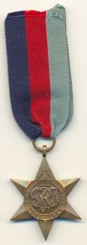John Johnston Tuton Blackwood

Robert Craig

Harold N Cramond

Hector Davidson

John Maxwell Dewar

James C Halliday

Kenneth I S M Leslie

Alastair Milne

James Nicholson

Kenneth R Normand

Alastair Simpson

J C Smith

Ronald Haig Wilson

Africa Star

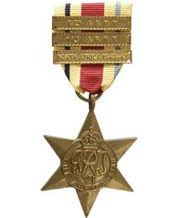

Harold N Cramond

Aircrew Europe Star

Alastair Milne

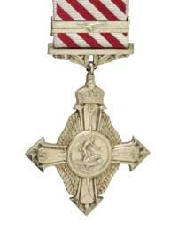Air Force Cross

James Rintoul Cellars

Army Foundation College

Inspirational Leadership Award

Ross McGhie

British Victory Medal

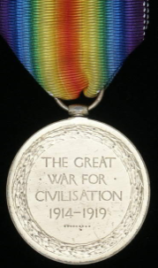David Stephen

British War Medal, 1914-20

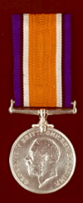David Stephen

Burma Star

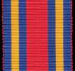John Maxwell Dewar

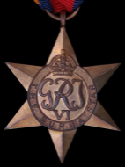

Croix de Guerre

(Belge)

1ère Classe

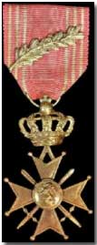

David Stephen

Defence Medal

Kenneth I S M Leslie

James Nicoll MacGregor

Alastair Milne

James Nicholson

Kenneth R Normand

W R Oliver

Sheena Page

George Ian Philp

Charles Ian Riddell

Robert Rodgers Scott

J C Smith

David Stephen

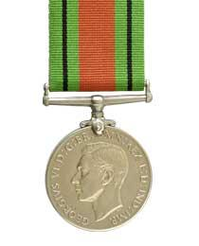

Stephen Bayne

Janet S Buchan

Elizabeth Buttercase

George D Calley

Robert Craig

Harold N Cramond

Hector Davidson

William A Doig

Wilma Duncan

James C Halliday

Margaret S Honeyman

Thomas Ireland

Distinguished Flying Cross

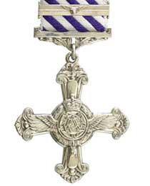

William Boyd

Alastair Simpson

France and Germany Star

Alastair Milne

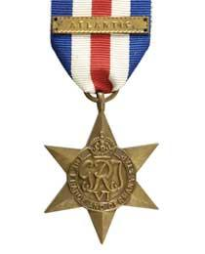Ronald Haig Wilson

General Service Medal

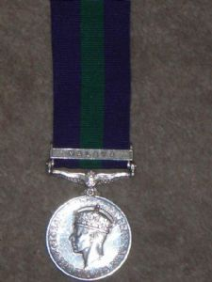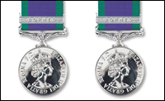

George Jobson

Alexander Maule

Thomas Penrose

Gulf Medal

1990-91



Alexander McBride Davis

Long Service & Good Conduct Medal

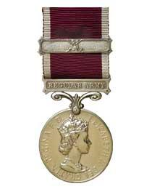

Alexander Maule

Jacqueline Gilchrist

Mentioned in Dispatches

James Rintoul Cellars

Robert Craig

Jean Sharp

NATO Medal

Former Yugoslavia

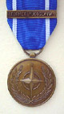

Alexander McBride Davis

Queen's Commendation for Valuable Services in the Air



Alexander McBride Davis

Philip Peter Williamson

Royal Air Force

Air Officer Commanding-in-Chief Fighter Command

Commendation

Alexander Maule

Air Officer Commanding No 1 Group

Royal Air Force

Commendation

Jackie Wheaton

Royal Marines

Commander 3 Commando Brigade

Commendation

Sarah Stedman

Territorial Decoration

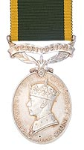

Angus Hood

John James Andrew Reid

UN Medal

Korea

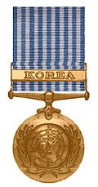

Alexander Maule

War Medal

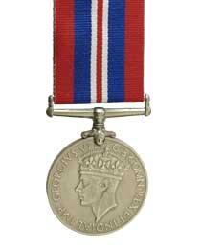

Stephen Bayne

John Johnston Tuton Blackwood

Ranald Brook

Janet S Buchan

Elizabeth Buttercase

George D Calley

Robert Craig

Harold N Cramond

Hector Davidson

William A Doig

John Maxwell Dewar

James C Halliday

Thomas Ireland

Kenneth I S M Leslie

James Nicoll MacGregor

Alastair Milne

James Nicholson

Kenneth R Normand

W R Oliver

George Ian Philp

Charles Ian Riddell

Robert Rodgers Scott

Andrew Brown Sinclair

J C Smith

Charles M Todd

Ronald Haig Wilson

**Police**

Long Service Medal

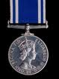Fred Gilmour**Professional**

**Bridge of Earn Hospital**

Dr McLeod Medal

for General Nursing Ability

Isabella Riddle

Prize for Gynaecological Nursing

Isabella Riddle

Senior Nursing, Dietetics and Tuberculosis

First Prize

Ann Duncan

**British Institute of Embalmers**

Fellow

David Jordan

**Farming**

Royal Agricultural Society

Fellowship

2000 Andrew D Arbuckle

Scottish Young Farmers

Ploughing Championship

Winner

1997 Richard Wilson

Sir William Young Award

for Outstanding Contribution to Livestock Breeding

2007 Ronnie Black

**Journalism**

Campaign Journalist of the Year

Iain Walker (1990)

Netherthorpe Communicator of the Year

Andrew Arbuckle (2012)

**Royal Institution of Naval Architects**

Past President

Marshall Meek

**Society of Antiquaries**

Fellow

John Greig

Will Maclean

**Rotary International**



**Challenge Enterprise**

James Winter

**Euroscola**

Lisa Anderson

Karen Burt

Stephanie Cavanagh

Kathryn Gemmell

Julie Geyer

Francesca Hill

Katie Wilson

**Paul Harris Fellow**

Alexander D M Green

Gavin J Reekie

Alexander Rennie

**Rotary Scholarship**

Ian G Docherty

**Rotary Youth Leadership Awards (RYLA)**

John Allan

Ruth Anderson

Lorraine Barrie

Nicola Bennett

Catherine Brearly

Nathan Brown

Eilidh Cage

Louise Cunningham

Gavin Curran

Christopher Gibb

Carolyne Hair

Ruth Henderson

Keira Herd

Sarah Hutchison

Sarah Kelly

Elizabeth McCanny

Andrew McCrone

Norman Macgregor

Iona McIntyre

Robert McLean

Dily Mordi

Paul Muirhead

Sophie Neil

Scott Pattie

Keiron Russell

Andrew Samson

Christopher Sweeting

Piers Turnbull

Kyle Watson

Ben Williams

**Scouting**

Silver Wolf

David Gordon

**Sport**

**Archery**

European Cham­pionships for the Disabled

Team Gold

David Cowieson

National Archery Trophy for the Disabled

David Cowieson

Scottish Disability Sport Archery Championships

Gold

David Cowieson

**Association Football**

North-East of Fife Inter-School League

Championship Shield

1951 Bell Baxter 2nd XI

**Athletics**

Bank of Scotland Championships

Under-17 800m

Gold

2009 Sarah Kelly (Record time: 2.10.56)

Celtic Games

Winner 1500m

2008 Sarah Kelly

Winner 800m

2008 Jenny Tan

Daily Record

Young Female Athlete of the Year

2009 Sarah Kelly

English Champion

1500m

2008 Sarah Kelly

Scottish Champion

Under-17 800m

2008 Sarah Kelly

Scottish Inter-Regional Championships

Senior 800m

Winner

2009 Jenny Tan

Under-17 800m

Winner

2009 Sarah Kelly

Under-17 1500m

Winner

2009 Sarah Kelly (Record time: 4.19.99)

Scottish Schoolboys’ Championships

Eric Liddell Trophy

for most meritorious performance

1959 David Whyte (half share)

National Standard Medals

220 Yards

1959 G Martin

200 yds Low Hurdles

1959 Lyle Croll

100 Yds Hurdles

1959 Lyle Croll

Shot Putt

1959 Joe Manson

High Jump

Winner

1959 David Whyte (5 ft 9 ins)

Open Long Jump

Winner

1951 Arthur Donaldson (20 ft 8 ins)

1959 David Whyte (22 ft 9 ins – Record)

Under-15 Relay

Second Place

1951 Bell Baxter

Scottish Schools Championships

Discus

Gold

1960 Catherine Sutherland (93’ 4” = Championship Record)

Pentathlon

1982 Jacqueline McCubbin 2nd Place

Shot

Gold

1960 Joe Manson (46’ 4”)

Scottish Senior Indoor Championships

Silver

2008 Jenny Tan

**Badminton**

Fife Schools Championships

Under-19 Singles

Boys Champion

2009 Harry Wilson

2012 Ciaran Russell

Runner-up

2012 Kieran Rickard

Under-19 Singles

Girls Champion

2008 Philippa Turnbull

2009 Eilidh Johnston

2010 Eilidh Johnston

Under-19 Boys’ Doubles

Winners

2008 CampbellMcLeod & Harry Wilson

2009 James Russell & Harry Wilson

Runners-up

2010 James Russell & Lewis Baird

Under-19 Girls’ Doubles

Winners

2008 Philippa Turnbull & Eilidh Johnston

2009 Eilidh Johnston & Amy Winters

2010 Eilidh Johnston & Amy Winters

Runners-up

2012 Fiona Cooper & Victoria Baird

Under-19 Mixed Doubles

Gold

2008 Philippa Turnbull & Campbell McLeod

Runners-up

2010 Eilidh Johnston & James Russell

Under-16 Singles

Girls Champion

2008 Eilidh Johnston

2012 Fiona Cooper

Runner-up

2012 Caitlin Brown

Under-16 Mixed Doubles

Gold

2012 Liam San Roman & Caitlin Brown

Runners-up

2008 EilidhJohnston & James Russell

Under-15 Singles

Boys Champion

Runner-up

2012 Liam San Roman

Under-14 Mixed Doubles

Runners-up

2010 Caitlin Brown & Liam San Roman

Under-13 Singles

Girls Champion

2009 Caitlin Brown

**Boxing**

Youth Lightweight Champion of Scotland

1962 Jack Allan

**Chess**

Fife Schools Championships

Champion

2006 Liam Ingram

2007 Francis Batchelor

2008 Liam Ingram

Team Champions

Fife Cup

2007 Jo Sinski, Finlay Dick, Liam Ingram & Francis Bachelor

2009 Connor Hainey, Oliver Twentyman, Finlay Dick & Nick Fisher

RUNNERS-UP

2011 Sean Morgan S2, Connor Jones S2, Angus Evans S1 and Jonathon Munro S1

**Combined Services Sportswoman of the Year**

1989 Jacqueline Gilchrist

**Cricket**

University of St Andrews Blue

John Maxwell Dewar

**Cross Country**

Fife Schools Championships

Gold

2004 Jennifer Kibble

2005 S1 Boys Zane Powell, Jonathan Failles, James McKerrow,& Aiden Anderson

2005 S2/3 Girls Sarah Kelly, Jenny Tan, Kiri Stone,& Rachel Richardson

2007 Jennifer Kibble

2007 Andrew Hood

2007 Sarah Kelly

Silver

Jennifer Tan

2005 Lucy Duff(S1)

2005 Jennifer Kibble(S4/5/6)

Lucy Duff, Sarah Mclntyre, Joanne Rearie,andLouise Pearson(S1 girls)

2007 Maya stone

Bronze

2004 Ryan Ritchie

2005 Jenny Tan(S2/3 girls)

2005Zane Powell(S1 boys)

2005 Andrew Hood, William Steele, Matthew Morgan& Iain Wilson(S2/3 boys)

2007 Ryan Ritchie

2007 Ross Hunter

2011 BBHS Girls

S4/5/6 Boys' Event

Gold

2008 Ryan Ritchie

Silver

2008 Andrew Hood

Boys' Team Event

Gold

2008: Ryan Ritchie, Andrew Hood, Connor Hawkins & Martin Rennie

S2/3 Boys' Team Event

Bronze

2008: Ross Hunter, Zak Campbell-Lochrie, Myles Morelli& Sandy Dawson

S2/3 Girls' Event

Bronze

2008 Maya Stone

S2/3 Girls' Team Event

Silver

2008 Maya Stone, Lucy Duff, Robyn Graham&Lauren McKinney

2009 Robyn Graham, Lauren McKinney, Kirsty Orr& Nicky Wilson

Scottish Schools Championships

Under-17

Gold

2008 Sarah Kelly

Under-15

Gold

2007 Sarah Kelly

Bronze

2006 Sarah Kelly

2008 Sarah Kelly

S1 Girls

Silver

2009 Jill Geyer

**Curling**

Hay Trophy

2009: Blair Jefrey, Iain Wilson, James Russell, Gregor Lawson & Cameron Cessford

2011: 3rd Place - Grant Thomson, Cameron Cessford, Gregor Bousie& Jasmine Cochrane

**Disability Sport Fife**

lifetime achievement trophy

Michelle Hill

**East Fife Sports Council**

16-21 Age Group

Winner

2008 Jenny Tan

**Equestrianism**

Scottish Championships

14-and–under

Show Jumping

2005: 1st Place: Rebecca Gatherum, Ross Hood, Nicole Spittle& Alis tair McKinney

Scottish Schools Equestrian Championships

Show Jumping

2007: 2nd Place: Louise Walker, Lauren smith, Lauren McKinney & Kimberley Irvine

Scottish Schools Rivals Cup

(Show Jumping)

Champion School

2008: BBHS (Rebecca Gatherum, Louise Christie, Sarah Gatherum & Kim Dawson)

Scottish Schools Show Jumping Championships

Senior Team Class

2007: 3rd Place Rebecca Gatherum, Louise Christie & Lauren Smith

Senior Individual

2007: 1st & 2nd Place Rebecca Gatherum

Scottish Schools Summer Show Jumping Trials

Senior Horse Open Champion

2007 Rebecca Gatherum

Scottish Schools Winter Show Jumping Trials

Senior Horse Open Champion

2008 Rebecca Gatherum

**Fly Fishing**

Scottish Youth Champion

2006 Grant Osler

**Golf**

Alfred Dunhill Links School Challenge

2006 3rd Place Chris Martin

British Army Champion

1959 George Will

1960 George Will

British Boys’ Champion

1956 John F Ferguson

British Youth Champion

1957 George Will

Duke of York Cup

1967 Gordon Kidd

Esso Golden Round

Winner

1965 George Will

Fife County Champion

Joan Barrie Lawrence

Fife Junior Schools Championships

Handicap Trophy

2006 Jamie Bruce, Connor McAndrew, Dominic Martin & Michael Ridley

Fife Schools Girls’ Championships

Team Trophy

1980 Winners: Dorothy Allan, Paula Douglas & Ruth Thomson

Team Scratch

2006 Winners: Claire Bain & Laura Hunter

Fife Schools Senior Boys’ Championships

Handicap Trophy

2011 Robbie Docherty

Team Handicap Trophy

1982 2nd Place: Mark Finnie, Scott Blyth, Neil Morrison and Alistair Ferguson

2011 Robbie Docherty, Ian Dawson, Ross Christie and John Nelson

Fife Senior Champion

Gordon Kidd (twice)

Northern Open Champion

1958 George Will

1963 George Will

Professional Golfers’ Association

Fellow

Sandy Smith

Scottish Boys’ Champion

1955 George Will

Scottish Ladies' Champion

Joan Barrie Lawrence

Singapore Open

Runner-up

1966 George Will

**Gymnastics**

Bertolazzi Memorial Cup

2012 Thomas Cameron

British Champion

Pommel Horse

2012 Thomas Cameron

Men’s All-round Scottish Championships

Under-14 Class

Winner

2012 Thomas Cameron

Scottish Schools Championships

Floor Champion

2005 Fiona Coyle

**Judo**

Scottish Champion

14/15 Age Group

Under 55Kg

2008 William Nelson

**Karate**

World Shokotan Chjampionships

Bronze

2011 Andrew Lennie

**Multi-Events**

Fife Schools Championships

Gold

Michael Brooks

Hollie Keanie Emma Fedo

James Hair

Emma Logan (2)

Ross McFarlane

Silver

Shannon Almond

Ian Anderson

Julia Fedoe

Jill Geyer

James Hair

George Horne

Lauren McKinney

Katy Tan

Harry Winter

Bronze

Julia Fedoe

Natalie Guy

Lauren McKinney

Connor Marchbank

Joanne Rearie

Katy Tan

**Paralympics**

Gold



Caroline Innes

Silver



Caroline Innes

Scotland's Greatest Paralympian

Caroline Innes

**Pole Vault**

Scottish Champion

Andrew D Arbuckle

**Road Relay**

Fife Schools Championships

Gold

Jennifer Kibble

2007 Sarah Kelly

Silver

Sarah Kelly

Kiri Stone

Bronze

2007 Jenny Tan

Senior Boys Team

Silver

2007 Connor Hawkins, Andrew Hood & Ryan Ritchie

Senior Girls Team

Gold

2007 Jenny Tan, Kiri Stone & Sarah Kelly

Silver

2008 Jenny Tan, Jaqueline Howie & Sarah Kelly

Bronze

2009 Lucy Duff, Lauren McKinney & Robyn Graham

S2/3 Girls Team

Gold

2009 Hollie Keanie, Kirsty Orr & Jill Geyer

Silver

2008 Lauren McKinney, Kirsty Orr & Robyn Graham

Bronze

2007 Lauren McKinney, Robyn Graham & Maya Stone

Scottish Schools Championships

S1 Road Relay

Gold

2006: Lauren McKinney, Katy Tan & Maya stone

Bronze

2005: Joanne Rearie, Lucy Duff& Sarah Jane Mclntyre

Over-15 Girls

Silver

2006: Jennifer Kibble

Bronze

2006: Jenny Tan

Over-15 Girls Team

Gold

2006: Jenny Tan, Kiri Stone, & Jennifer Kibble

S1 Boys

Gold

2006: Ross Hunter

S1 Girls

Gold

2006: Maya stone

Bronze

2006: Lauren McKinney

Under-15 4x100m Relay

Gold

2004: Sam Spittle, Graeme Johncock, Chris Fusaro&Luke Dyke

Under-15 Girls

Gold

2006: Sarah Kelly

Under-15 Girls Team

Silver

2006: Sarah Kelly, Joanne Rearie & Lucy Duff

Under-17 4x100m Relay

Gold

2005: Sam Spittle, Graeme Johncock, Chris Fusaro&Girvan Imrie

Under-14 Girls' Race

Silver

Sarah Kelly

Jennifer Tan

Team

Silver

2008: Maya Stone, Robyn Graham, Jenny Tan & Sarah Kelly

Rugby

Bell Lawrie Under-18 Scottish Schools Rugby Championships

Winners

2007 Bell Baxter 1st XV

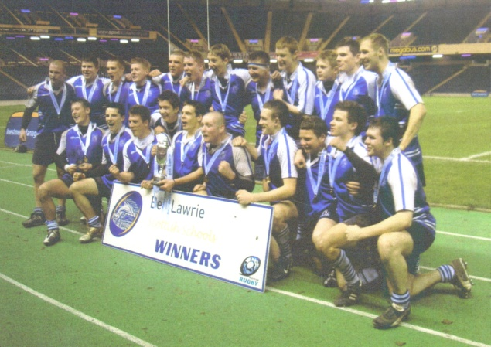

Winners of the Bell Lawrie Trophy

Back row, left to right:

Chris Fusaro, Bruce Mcintosh, Michael Fedo, Chris Martin, Darren Lorrimer, Grant Henderson, Andrew Young, Donald Fraser, Ian Dawson, Conor Dow, William Wardlaw, Graeme Johncock

Front row, left to right:

Peter Home, Robbie Williamson, Steven Wilson, Ross Aitken, Chris Mason (captain), Josh Fox-Clark, Rory Drummond, Matthew Keeble, Stewart Lathangie, Paul Robertson

(Photograph courtesy of Chris Fusaro's parents)

Brewin Dolphin

Plate

2012-13 Bell Baxter Under-16 XV

(Joint Winners with Jedburgh GS)

Scottish Schools Sevens Championship

Winners

1975 Bell Baxter First Year XV

2006 Bell Baxter Senior Boys

**University of St Andrews Blue**

John Maxwell Dewar

**Scottish Sports Council**

Volunteer Investment Programme Award

Gina Arbuckle

**Scottish Sportswoman of the Year**

Liz Toulalan

**Shooting**

Rifle

Scottish Champion

Angus Hood

**Swimming**

British National Age Group Championships

100m Freestyle

Age Group Winner

2013 Kirsty Simpson

100m Backstroke

Age Group Winner

2009 Kirsty Simpson (Scottish Record: 1.07.01)

Age Group Silver

2013 Kirsty Simpson (Scottish Record: 1.04.09)

100m Fly

Age Group Silver

2013 Kirsty Simpson

200m Backstroke

Age Group Silver

2013 Kirsty Simpson

East Fife Sports Council

Disability award

2009 Stefan Hoggan

**Fife Schools Championships**

Most Meritorious Swimmer

2010 Roisin Donnelly

400m Freestyle

Gold

2006 Philip Kelly

200m Backstroke

Gold

2010 Kirsty Simpson (Record time)

Silver

Tom Rus­sell

16+ 200m Freestyle

Gold

2010 Ross Hunter

200m breaststroke

Gold

2010 Roisin Donnelly (Record time)

16+ 200m Breaststroke

Gold

2012 Ruairidh Haig

14-15 yrs 200m breaststroke

Gold

2012 Kirsty Simpson (Record time)

Silver

2010 Ruairidh Haig

2012 Alex Reid

12-13 yrs 200m Freestyle

Gold

2012 Owen Greene

12-13 yrs 200m Butterfly

Gold

2010 Owen Greene

14-15 yrs 200m Medley

Silver

2010 Kirsty Simpson

100m Backstroke

Gold

2010 Kirsty Simpson (Record time)

Bronze

Ben Brown

2008 Ross Ballingall

2008 Kirsty Simpson

16+ 100m Backstroke

Gold

2012 Ewan Simpson

14-15 yrs Backstroke

Silver

2012 Kirsty Simpson

100m Breastroke

Gold

2008 Roisin Donnelly (Record time)

Silver

2008 Ross Hunter

2008 Sam Robinson

2010 Kirsty Simpson

Bronze

Gina McDermid

2008 Jordan Buist

2010 Ruairidh Haig

2010 Owen Greene

16+ 100m Breastroke

Gold

2012 Ross Hunter

14-15 Yrs 100m Breastroke

Gold

2012 Alex Reid

100m Butterfly

Gold

2010 Owen Greene

Silver

2008 Ross Boyter

2008 Roisin Donnelly

2008 Andrew Hood

Bronze

2008 Connor Hawkins

12-13 yrs 100m Butterfly

Gold

2012 Owen Greene

14-15 yrs Butterfly

Silver

2012 Kirsty Simpson

100m Freestyle

Gold

2010 Ross Hunter

Silver

2008 Ross Hunter

2008 Sam Robinson

2010 Kirsty Simpson

Bronze

Kyle Watson

2008 Ewan Simpson

2010 Ewan Simpson

4x50m Relay

Gold

Kyle Watson, Ben Brown, Philip Kelly& Tom Russell

Schools International

200m Breaststroke

Gold

2009 Roisin Donnelly

100m Breaststroke

Silver

2009 Roisin Donnelly

Scottish Amateur Swimming Association

John Y Coutts Award

Gina Arbuckle

Scottish Schools Championships

400m Freestyle (open age)

Bronze

2006 PhilipKelly

100m Freestyle (Over 17)

Gold

2011 Ross Hunter

100m Freestyle (15/16 Years)

Silver

2011 Ewan Simpson

Backstroke

Silver

2010 Kirsty Simpson

200m Backstroke

Silver

2010 Kirsty Simpson

200m Breaststroke (15/16 years girls)

Gold

2009 Roisin Donnelly

2010 Roisin Donnelly

200m Medley (13/14 years girls)

Gold

2006 Sarah Kelly

100m Breaststroke (15/16 years girls)

Silver

2009 Roisin Donnelly

2010 Roisin Donnelly

**Tae Kwondo**

World Championships

12-14 Age Group

Silver

2008 Liam Murdoch

Bronze

2008 Chris Mercer

**Track and Field**

Fife Schools Championships

Gold

Luke Dyke

Steven Ferns

James Hair

Graeme Johncock

Scottish Awards

Under-17 Track & Field Athlete of the Year

2009 Sarah Kelly

Scottish Schools Indoor Track and Field Championships

Over-16 Girls' 800m

Gold

2008 Jenny Tan

Over-16 Girls' 300m

Silver

2008 Jenny Tan

under-16 girls' 1500m

Gold

2008 Sarah Kelly

Scottish Schools' Championships

Gold

Iona McIntyre

Joe Manson (Shot)

Callum Rankin

Lyndsey Russell

Catherine Sutherland

Jenny Tan

Liz Toulalan

Silver

Sarah Kelly

2010 Ben Logan (Shot)

2010 Ben Logan (Discus)

Emma Logan

Iona McIntyre

Bronze

Michael Brooks

Barry Normand

Scottish Under-20 Championships

Bronze

2008 Ben Logan

**University of Glasgow**

Bob Wilson Memorial Trophy

Neil Dickson

**Variety Club of Great Britain**

**Disabled Sportsman Award**

Caroline Innes

**Winston Churchill Fellowship**

Liz Toulalan

**Young Disabled Sportswoman of the Year**

1993 Caroline Innes